Step 1: Select a student in the student context area.
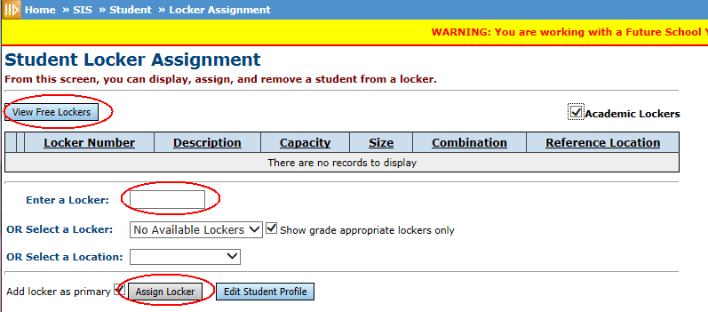
Step 2: Assign Student Locker Home » SIS » Student » Locker Assignment

Step 3: If you know what locker number to assign just enter the number in the Enter a Locker field and press Assign Locker.
If you do not know a locker to assign you can continue to Step 4 else continue to Step 7
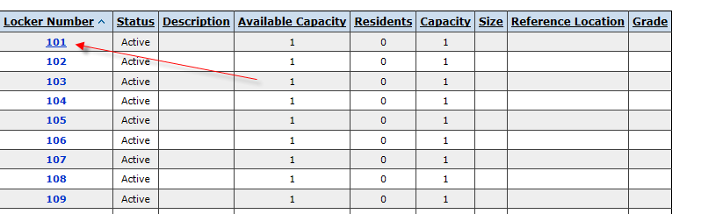
Step 4: Click the View Free Lockers button.

Step 5: Click a locker off the list you would like to assign. Make sure it is available.
Step 6: If this is the primary locker, check the box, then press OK button.
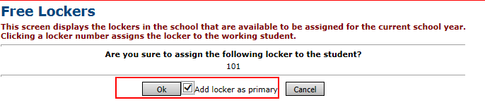
The Add Locker as Primary checkbox above is unchecked by default, so be careful to check this if it is supposed to be the primary locker.

Step 7: Verify the locker was added. If it is the primary locker it should have a gold star else the star will be white. To make the locker a primary, click on the star.
